    Name | Shubham Sarang
Roll No | 1345
Topic | Queues
Title of Program | Priority Queue

CODE:
/*
Name: Shubham Sarang
Roll no: 1345
Unit 4: Queues
Program: Priority Queue
*/

#include<iostream>
#include<conio.h>

using namespace std;

//1. Node template
class PNode
{
public:
int data;
int priority;
PNode *next;
};

//2. Queue template

class PQueue
{
PNode *front;
public:
PQueue()
{
front = NULL;
}
void Enqueue(int x, int p);
void Dqueue();
void PeekFront();
void PeekRear();
void Display();
};

//3. Functions

void PQueue::Enqueue(int x, int p)
{
PNode *t = new PNode();
t->data = x;
t->priority = p;
t->next = NULL;

//first node
if(front == NULL)
{
front = t;
return;
}
//Traverse in order
PNode *tmp = front;
PNode *prev = NULL;

while(tmp != NULL && tmp->priority < t->priority)
{
prev = tmp;
tmp = tmp->next;
}

//Insert t at the correct position in the queue

if(tmp == front) //Front node Insertion
{
t->next = front;
front = t;
}
else if(tmp == NULL) //Last node insertion
{
prev->next = t;
}
}

void PQueue::Dqueue()
{
PNode *tmp = front;
if(front->next == NULL)
{
front == NULL;
}
else
{
front = front->next;
}
cout<<"Element "<<tmp->data<<" dequeued with priority "<<tmp->priority;
delete tmp;
}

void PQueue::PeekFront()
{
PNode *tmp = front;
cout<<"Element at the front is "<<tmp->data<<" with priority "<<tmp->priority;
}

void PQueue::PeekRear()
{
PNode *tmp = front;
while(tmp->next != NULL)
{
tmp = tmp->next;
}
cout<<"Element at the front is "<<tmp->data<<" with priority "<<tmp->priority;
}

void PQueue::Display()
{
if(front == NULL)
{
cout<<"Empty Queue";
return;
}
PNode *tmp = front;
cout<<"Data | Priority \n";

while(tmp != NULL)
{
cout<<tmp->data<<" | "<<tmp->priority<<"\n";
tmp = tmp->next;
}
}

//4. Menu

int main()
{
int ch, num, pri;
PQueue p;

while(1)
{
system("cls");
cout<<"***Priority Queue*** \n\n";

cout<<"1. Enqueue \n";
cout<<"2. Dequeue \n";
cout<<"3. Peek front \n";
cout<<"4. Peek rear \n";
cout<<"5. Display queue \n";
cout<<"6. Exit \n";

cout<<"Enter your choice: ";
cin>>ch;

switch(ch)
{
case 1:
cout<<"Enqueue element: ";
cin>>num;
cout<<"Enter priority: ";
cin>>pri;
p.Enqueue(num,pri);
getch();
break;
case 2:
cout<<"Dequeue element: ";
p.Dqueue();
getch();
break;
case 3:
cout<<"Peek front: ";
p.PeekFront();
getch();
break;
case 4:
cout<<"Peek rear: ";
p.PeekRear();
getch();
break;
case 5:
cout<<"Display queue: \n";
p.Display();
getch();
break;
case 6:
exit(1);
break;
default:
cout<<"Wrong opt bruv";
getch();
break;
}//end switch
}//end while
}//end main
OUTPUT: ADD ELEMENT:
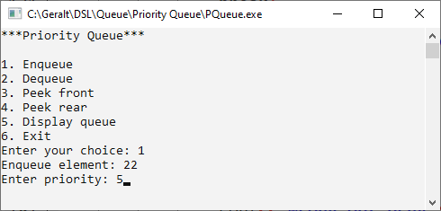
Display:
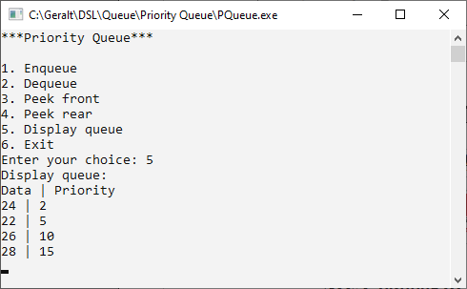
PeekFront:
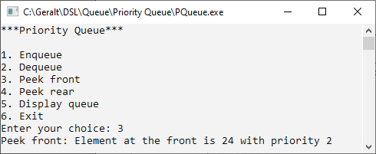
PeekRear:
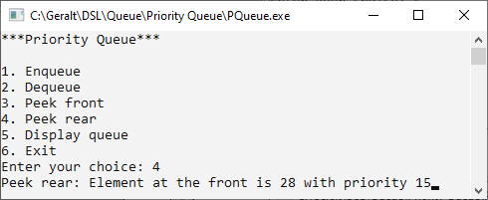
Dequeue:
